Reading Response Journal for College Writing I

What the Journal Is
Your journal is a record of your reactions to the assigned readings for this class, and it’s also where you’ll do some of your in-class informal writing. You’ll write your journal entries by hand in a composition notebook.

The Purpose of the Journal
Keeping the journal will develop your critical reading skills as you read carefully and analytically, and note your responses. This will help you develop as an active learner, an expressive and articulate reader, and a scholar who sees questions as a means for furthering discussion and learning. The journal will help you prepare for class discussions. Most importantly, one of the best ways to develop your formal, high-stakes writing is to do lots low-stakes, informal writing.

What Kind of Writing You’ll Do
The writing in your journal will for the most part be informal—although sometimes you’ll be asked to respond to a prompt or template that includes some formal language. Here you can write in your natural voice and not worry too much about grammatical errors and spelling. Your journal is a place to generate ideas, not edit yourself. Don’t worry about sounding super-smart, using big words, or writing a masterpiece. Just write the way you’d talk in class, for example, or the way you’d explain an idea to someone you respect but are comfortable with.

What You’ll Write About
There will be an entry due for each class day. In the calendar you received for the course, you’ll see a “Journal assignment” for each date, asking you to answer a specific question in the textbook, or giving you your choice of questions. I’ll also have you do some of your in-class brainstorming and freewriting in your journal notebook.

Requirements
Your assigned journal entries should be one full page to two full pages long, and handwritten neatly enough for me to read them. At the top of the page, write the due date and write out the question you’re responding to so I’ll know what you’re addressing when I read it. (For instance. October “Why does Carl Dennis’ poem end with an urging to write a letter?”)
For the sake of legibility, write only on the front of each page, not on both sides. If you make a mistake, don’t tear out the page, just cross out what you’ve written and go on. I’ll want all the pages to still be in the book at the end of the term.
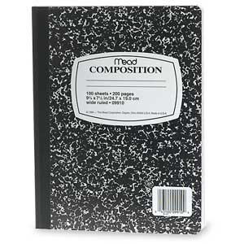

Evaluation
I want you to keep up with your journal every week, so I may look at them at any time. You’ll also hand in your journals at mid-semester and at the end of the semester for grading. I’ll grade the journals on punctuality, thoroughness, demonstrating knowledge of the assigned reading, and answers relevant to the assigned question or questions. I hope to see you really wrestling with the ideas in the readings, and will want you to see you experimenting with your writing.

Your journal counts for 20% of your grade for the course.

